# CS 255 System Design Document

Michael Wood

SNHU

Professor Eppenger

02/23/2025

## UML Diagrams

### UML Use Case Diagram

### UML Activity Diagrams

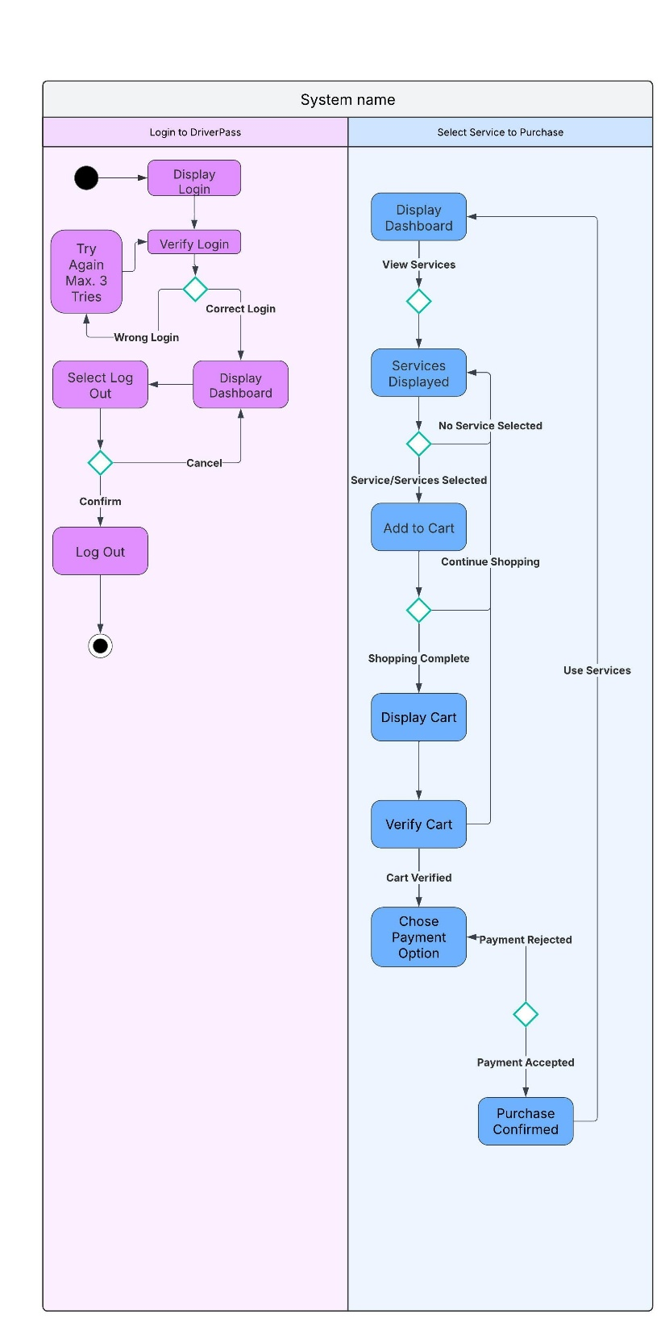

### UML Sequence Diagram

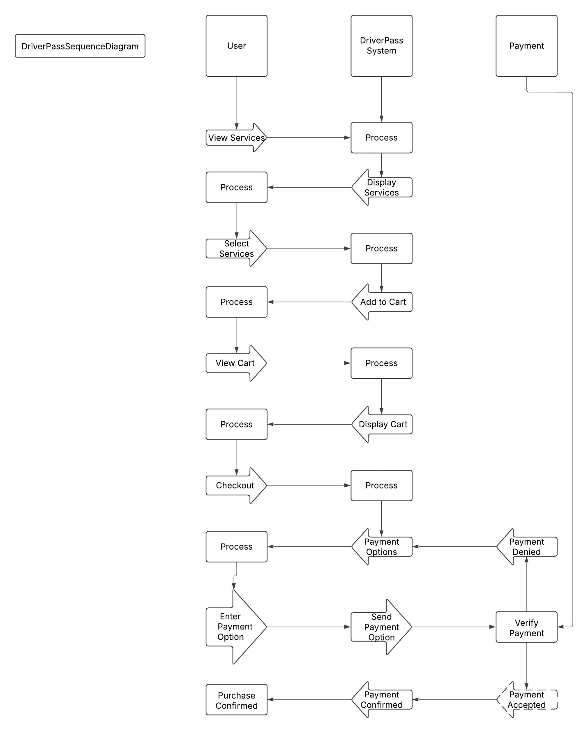

### UML Class Diagram

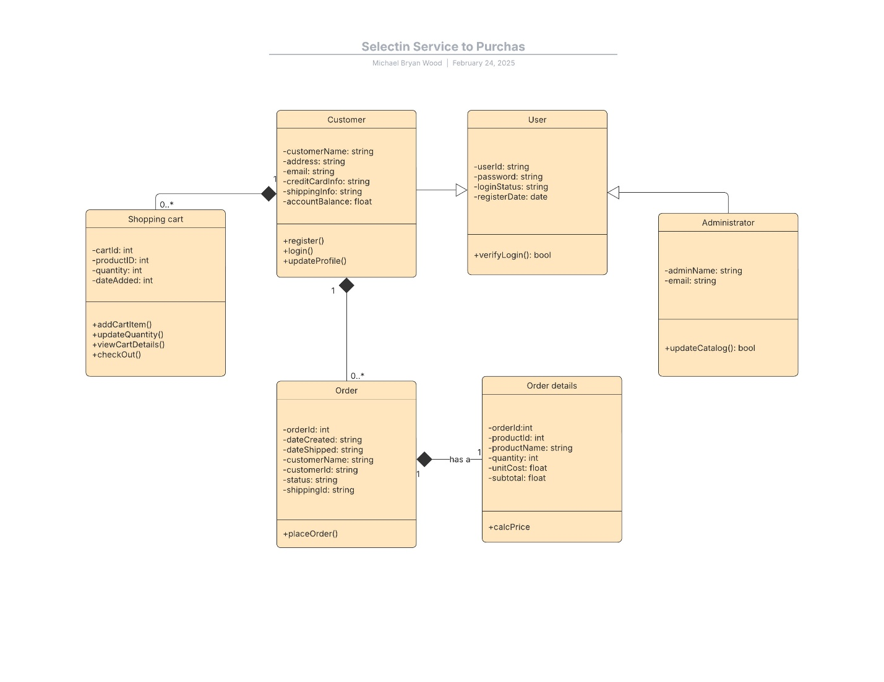

## Technical Requirements

Users must have a hosting provider to view the DriverPass app through their web browsers. It is best to hire someone else to handle hosting services. That way, DriverPass will not have to worry about things like server repair and other similar tasks. The program needs to connect to a collection of customers and their account information, as well as a service that verifies users when they log in. The DriverPass app also needs to connect to an outside payment service to accept funds from users. In the same way, being able to get into the DMV will be necessary to keep laws and driver standards up to date.